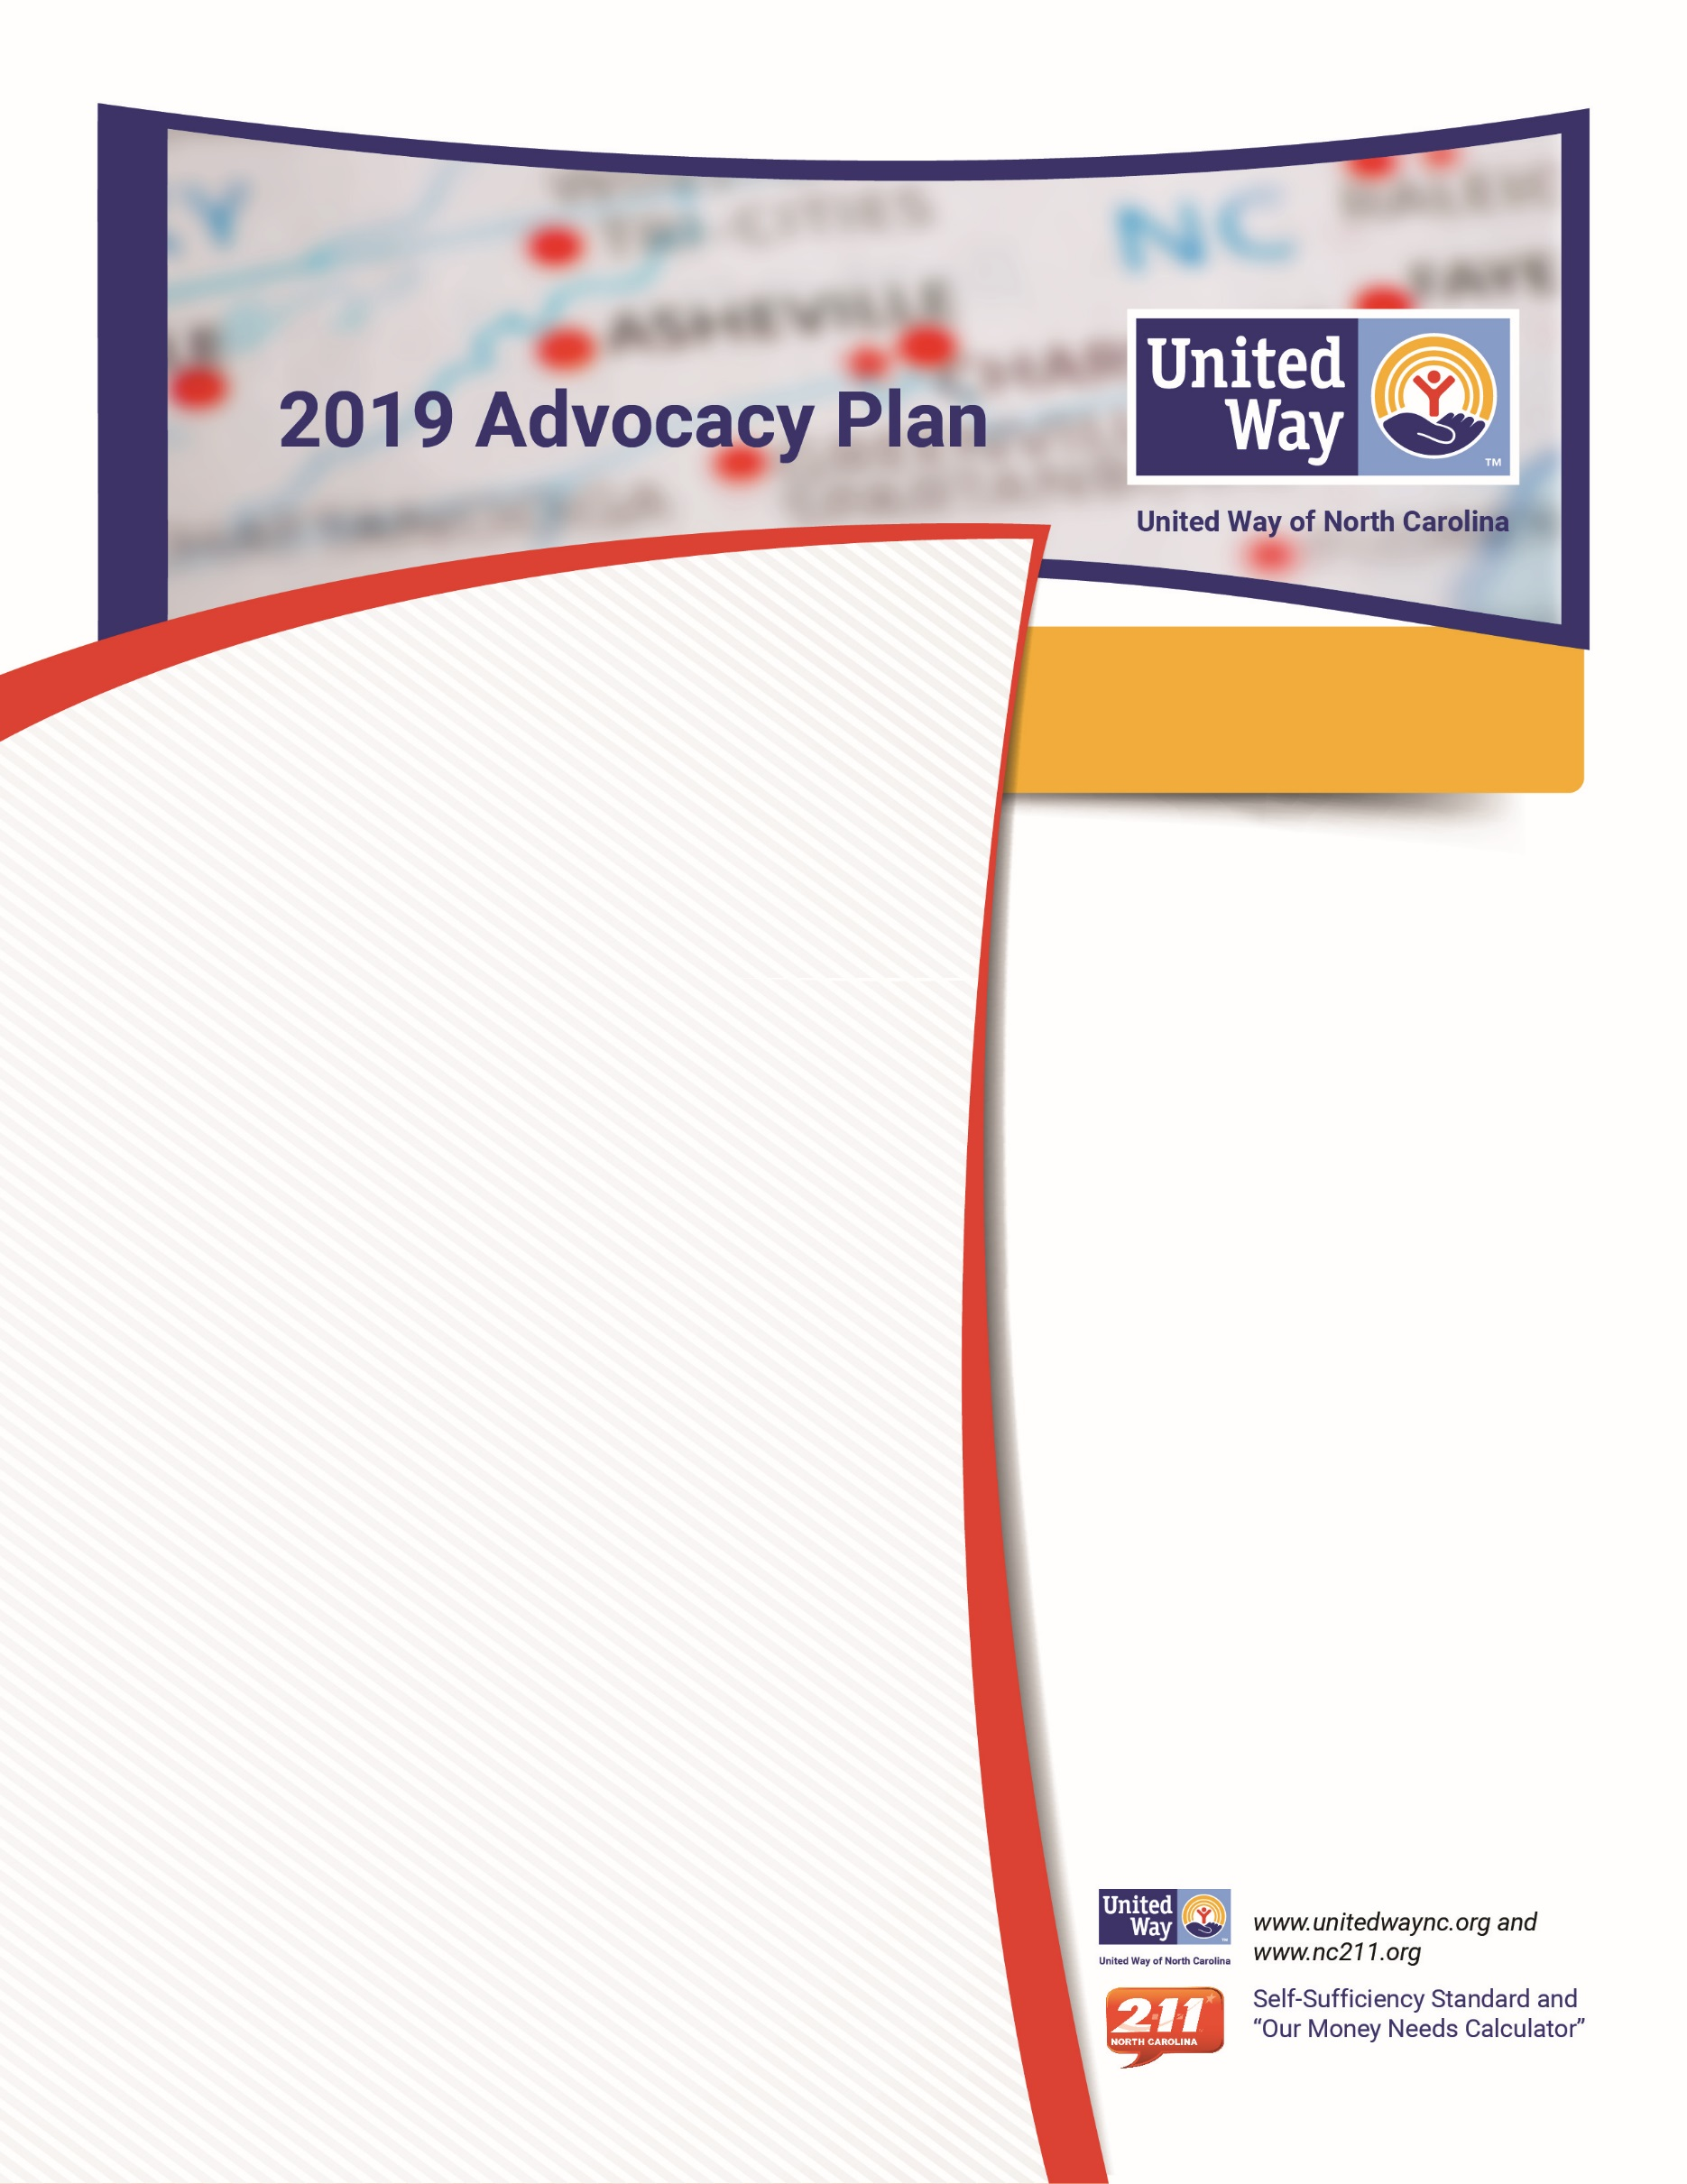
Establish a recurring financial partnership with the state of North Carolina that ensures 24/7/365 access to NC 2-1-1. UWNC invests $800K annually.
Raise awareness of what it takes to make ends meet for working families using the Self-Sufficiency Standard, “Our Money Needs Calculator” and other resources.
Support the North Carolina statewide nonprofit sector to ensure a healthy and vibrant nonprofit community that address challenges facing North Carolinians with efficiency and innovation.
Monitor and track policy and budget allocation activities that impact service delivery of quality education, financial stability, and healthy living; and seek to advance other core issues that align with United Way’s work.
UWNC Advocacy Goals
for 2019 are to:
United Way of North Carolina (UWNC) is a network of
53 member organizations – each led by a local volunteer board that defines advocacy, community investment, and problem-solving priorities for their community. UWNC leads the mutual vision in North Carolina to engage communities and identify resources, enhancing the well-being of North Carolina families. UWNC believes that strong communities require a thriving charitable sector with government, business, non-profit, and private partners who mobilize volunteers and initiate innovative solutions to address community challenges such as food insecurity, affordable housing, quality education, and more. Collectively, United Ways in North Carolina invest more than $90 million annually to assist families and improve the quality of human life in North Carolina.
As a statewide, nonpartisan voice for the United Way community, UWNC leads advocacy efforts in North Carolina to:
- Raise awareness of the critical issues facing local communities, activate volunteers, and initiate solutions for change;
- Address and support policies which:
Lead to a quality education for all children and youth, including early learning and reading on grade level.
Support working families to achieve financial stability through connection to vital resources that bridge the gap between their financial crunch and self-sufficiency.
Promote healthy living for North Carolinians of
all ages.

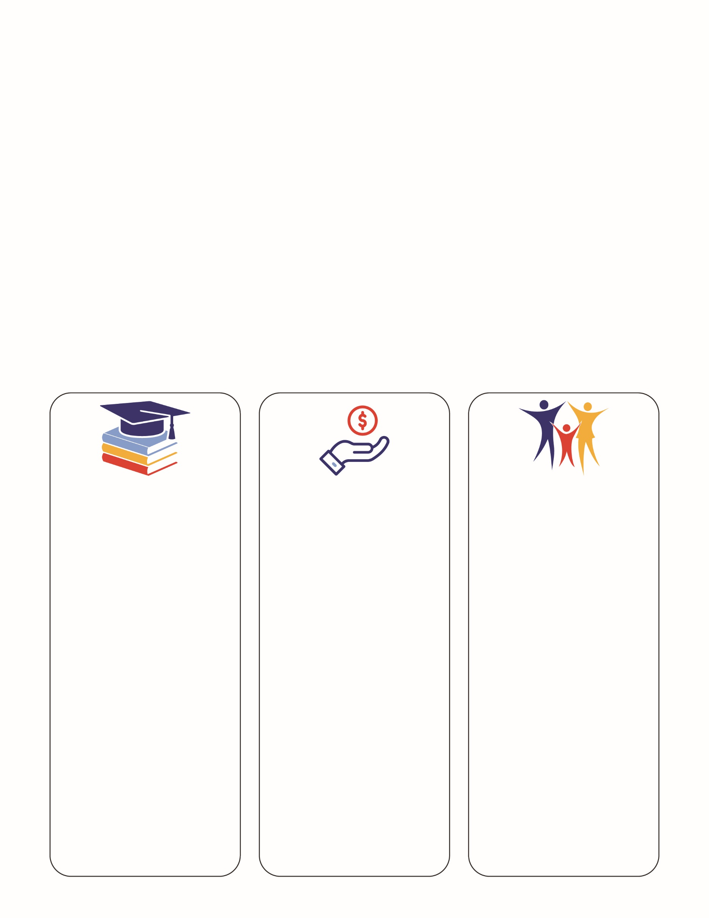
To support Advocacy Goals UWNC will:
- Oversee UWNC’s state advocacy and communications consulting services throughout 2019.
- Educate and train the statewide network at the local level for greater grassroots involvement especially as it relates to NC 2-1-1 recurring funding.
- Inform the statewide network of and state or federal government activity, initiating call to actions as appropriate.
- Create opportunities for one-on-one engagement between UW leadership and elected officials for discovery and support of local UW work that aligns with policy and/or budget changes.
- Continue to participate in discussion with community coalitions who are highly engaged in federal and NC tax structure changes and share facts and action opportunities with the field.
- Organize a Jones Street Day at the legislature to support statewide advocacy goals and promote local service priorities – March 26, 2019.

Local United Way organizations can support these advocacy goals by:
- Building relationships with state policymakers in their districts to review UWNC policy goals and discuss their local priorities, offering connection to NC 2-1-1 and Self-Sufficiency Standard information.
- Participating in advocacy efforts through engaging in any necessary call to actions, Jones Street Day, and face-to-face visits with their district’s elected officials.
- Aligning state advocacy goals with their regional priorities/goals
HEALTHY LIVES & COMMUNITIES
Access to Healthcare
Senior Services
Homelessness
STATE
- Health Coverage Access
- No Wrong Door and Alzheimer’s Plan support for seniors
- Medicaid Expansion
- Healthy living initiatives for families
- Diabetes Initiative
- Coordinated Assessment

FEDERAL
- Federal Health Plan
- CHIP

Civic Health Index
County Health Ranking
Cone Health Report
National healthcare Expenditures
Community Pulse (Mecklenburg only)
FINANCIAL STABILITY
Financial Wellness
Work Supports
Workforce Development
STATE
- Self-Sufficiency Standard & “Our Money Needs Calculator”
- Establish State EITC
FEDERAL
- Child Tax Credit
- VITA
- SNAP

Self-Sufficiency Standard
State of the South
211 Counts
U.S. Economic Forecasting
U.S. Labor Market
N.C. Labor Market

EDUCATION
College Readiness
K-12 Graduation Rate
Grade Level Reading
STATE
- Early learning priorities
- Dolly Parton Imagination Library
- Middle School Success
FEDERAL
- Childcare Development Block Grant
- ESSA
- State funding for early learning

College Readiness
NC Public Schools
Literacy Facts
Best NC
Child Care Deserts

